Assignment #10: Optical Interference

- A Diffraction grating with 500 lines per cm is placed in the path of a laser beam. How far from the optical axis are the first-order and second-order bright spots if the distance from the diffraction grating to the viewing screen is 2 meters?

- You are attempting to measure the frequency of a laser. A CD has an average of 3000 lines per centimeter. The first bright spot is seen at a 25 degree angle from the central reflection. What is the frequency of the laser?

- A water/soap bubble appears to be primarily green (l=5.3 x 10⁻⁷ nm in empty space). If the index of refraction of the soap bubble is 1.35, what is the thickness of the bubble (assume that the bubble is as thin as possible for this condition to occur.)

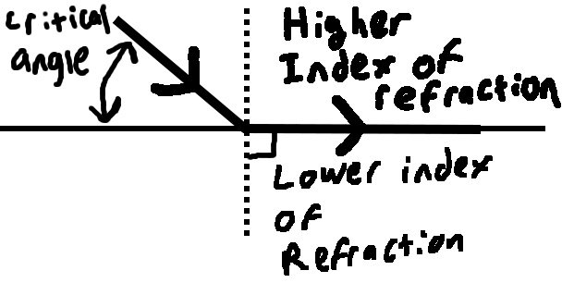
- When light goes from a medium with a higher index of refraction to a medium with a lower index of refraction, it bends away from the normal. The critical angle is defined as the angle at which light must approach an interface such that the angle the Ray is refracted at is 90 degrees. Calculate the critical angle for the following materials:
  - Water (n=1.33) to air (n=1.001)
  - Glass (n=1.6) to water (n=1.33)
  - Diamond (n=1.9) to vacuum (n=1)

